Lecture 1 : Introduction to microservices

# Lecture 2 : What are the types of communication for microservices?

# Lecture 3 : How to do Distributed Transactions the RIGHT way? Microservices

# Lecture 4 : How Event-Based Communication enhances Microservices Architecture?

# Lecture 5 : Types of coupling in microservices and how to reduce it

# Lecture 6: Monitoring Basics!

# Lecture 7: Service Discovery in Microservices

# Tutorial 8 :- Side Car Pattern in Microservices |

# Tutorial 9 : What is event sourcing and how to apply it?

# Lecture 10 : Introduction to circuit breaker in microservices

Lecture 1 : Introduction to microservices

**Microservices :** service that does one thing very well and interact to other service

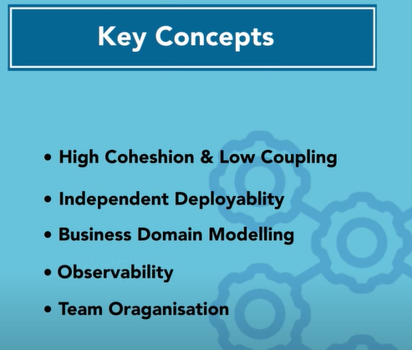

**Architecture of microservices**

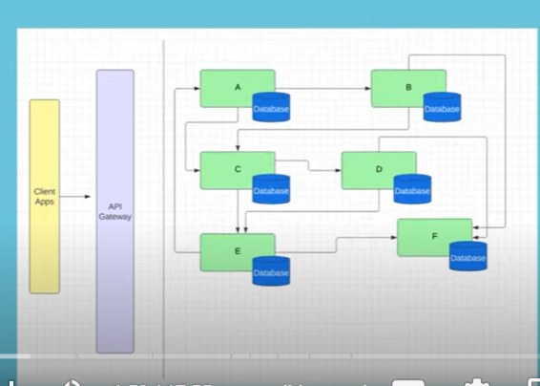

Every single service is a different component with its dedicated database and api gateway to route it

1. **High cohesion and low coupling**

All the functionalities which is related to that service sit inside that service that’s why we want our service to be highly **cohesive**

**In** m/s architecture m/s can talk with each other but they should not coupled on each other more. They should not use common database

**Coupling** means if the services are too much depend on each other , know too much about each other share a common source or database that means services are coupled with each other

1. **Business domain model**

In m/s architecture the services are divided as per business domain or business feature

E commerce

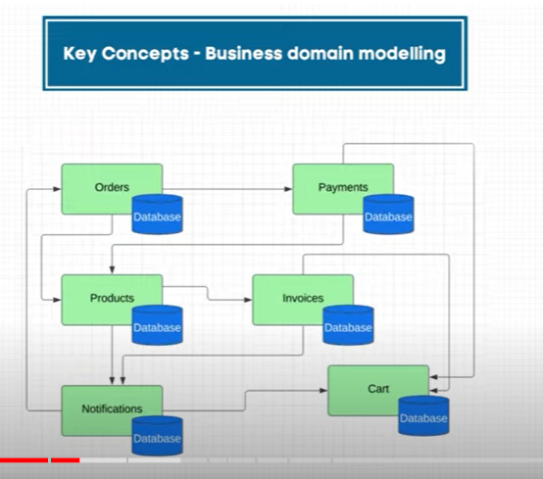

Services are modeled around the business domain.

1. **Independent deployability**

You should able to deploy our services independent of each other.

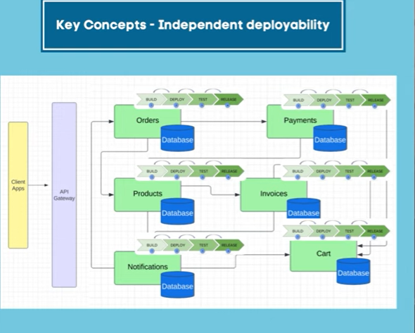

**Note** : every service has a dedicated pipeline

1. **Independent scaling**

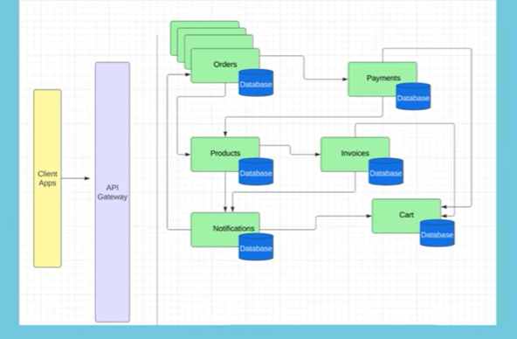

**Note :**  we can increase the instance of order if order is increasing

1. **Observability**

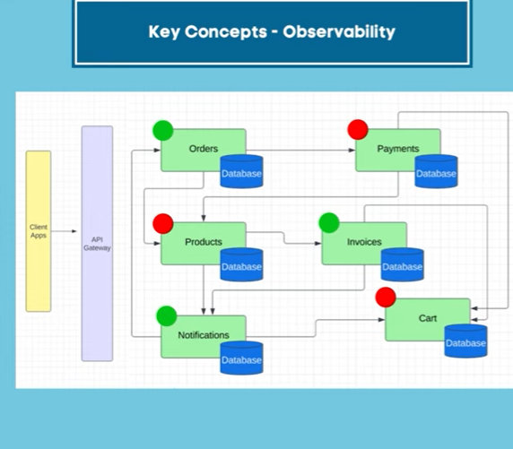

**We can**  easily see if any of the service is degraded or not

1. **Resilience**

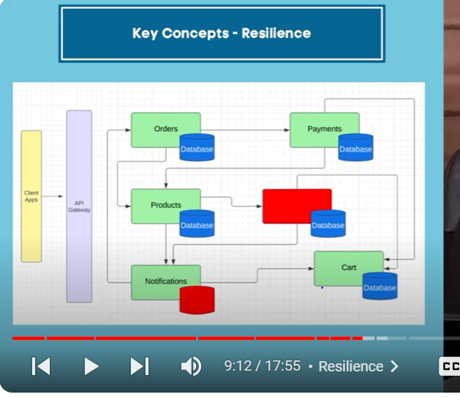

**If one of the service is down ,** it should not effect other system, the system should handled fault tolerance so that failures should not travel the system. This ensure even part if the system is failing but whole system will not come down.

**G: team organization**

**Few more advanatages**

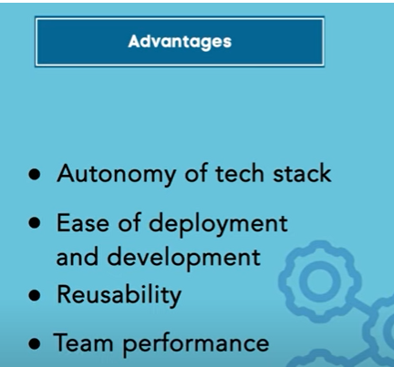

1. Autonomy of tech stack

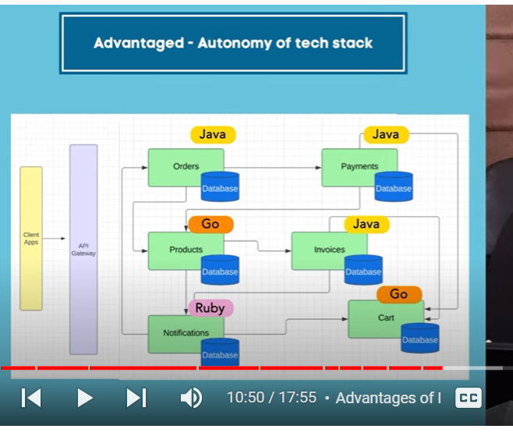

We can choose different databases

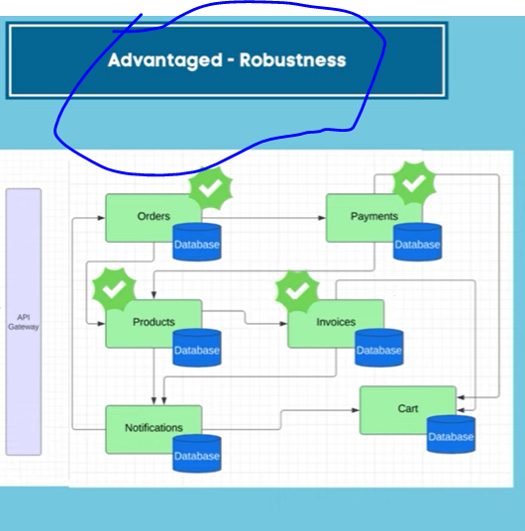

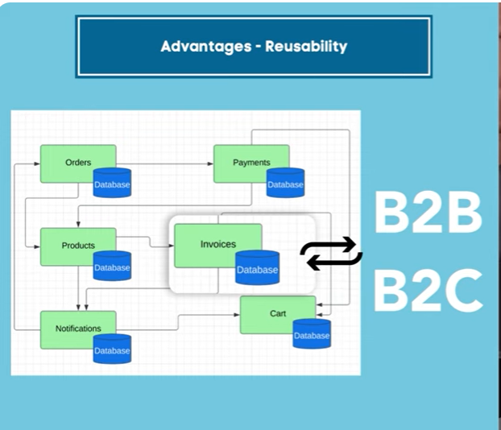

**Downside of Microservices**

**Cost**

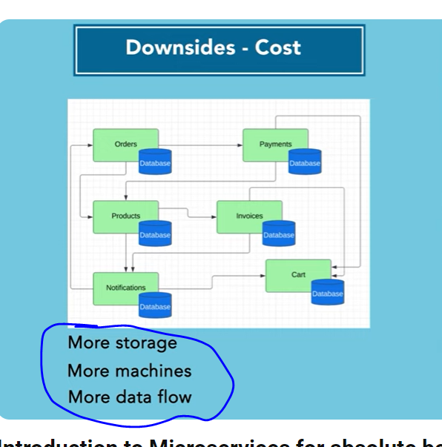

**Note :**

**we need to invest a lot in logging , monitoring and tracing of data**

**different database need to maintain**

**data consistency**

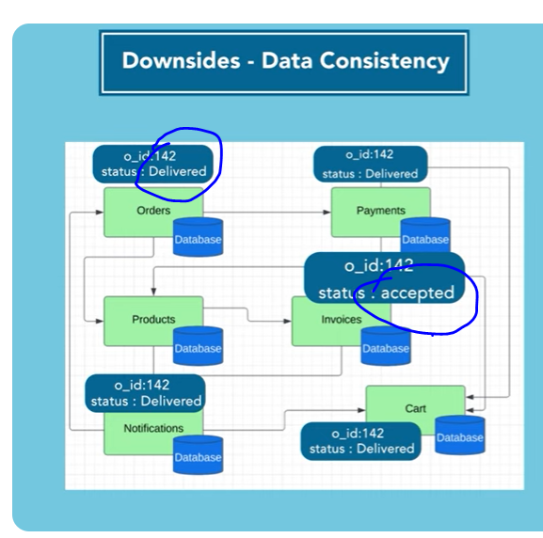

# Lecture 2 : What are the types of communication for microservices?

# 

# 2 types communication in m/s :----

# Synchronous blocking

# Asynchronous non-blocking

# 

# 

**Asynchronous non blocking :**  the microservice send some kind of data or events or request to another microservice and does not wait for response and it will not block any of the operation in the meantime

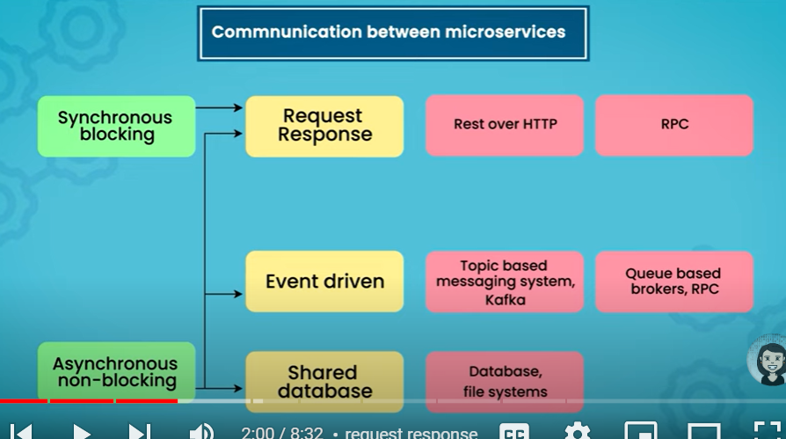

Asynchronous also uses **request response**

**These**  are three diff types of architecture :-----

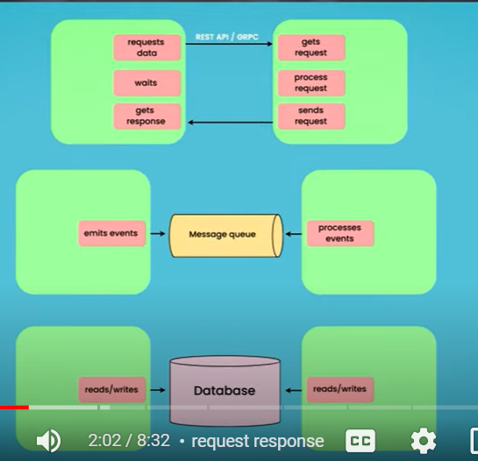

1:------------------- **request response architecture**

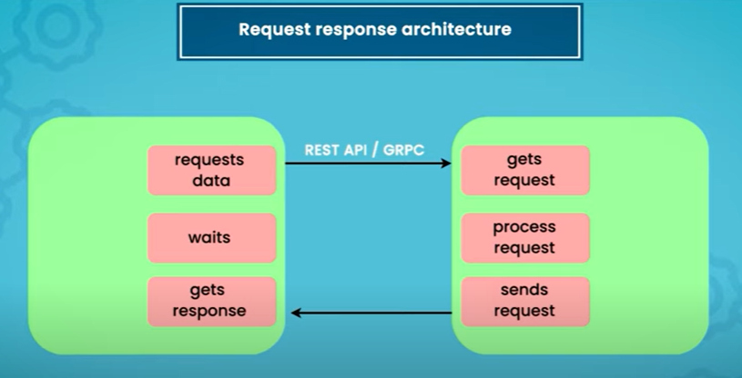

**In**  request response architecture we request the data over rest api or gprc or rpc, we get the response,

The process on the calling microservice either wait for the response or once it will get the response it will continue

**In asynchronous** : it will not wait for response but once it will get it will process it

2----------------------------- **Event driven architecture**

**In case of event driven architecture** we rely on messaging system.

It can be **queue based or topic based messaging system**

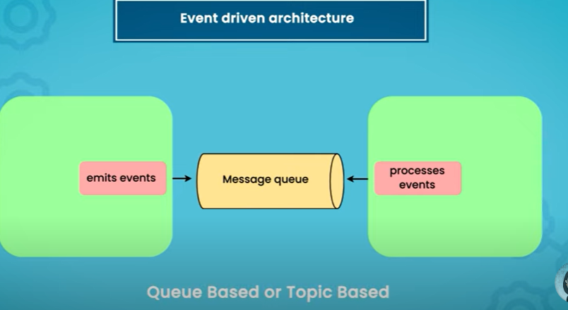

3------------------------------- **shared database architecture**

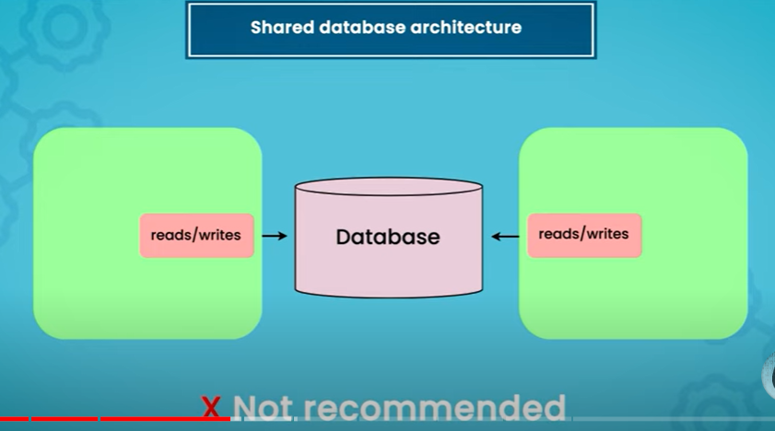

**It is not a recommended approach but**  we will see usecase where it can be used.

In this case we have a common database between two microservices

**Let start example with synchronous blocking microservices**

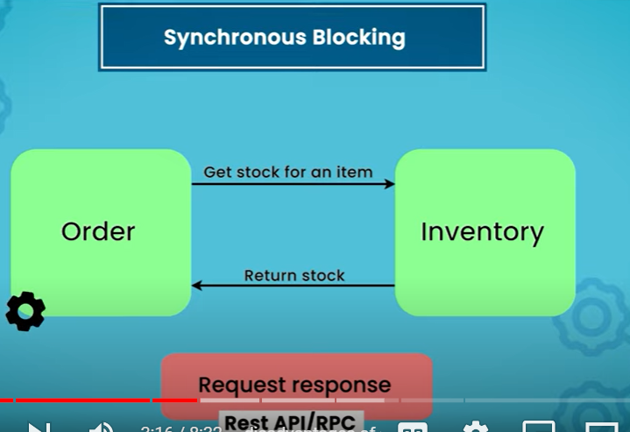

**Disadvantage :**  time can be taken more

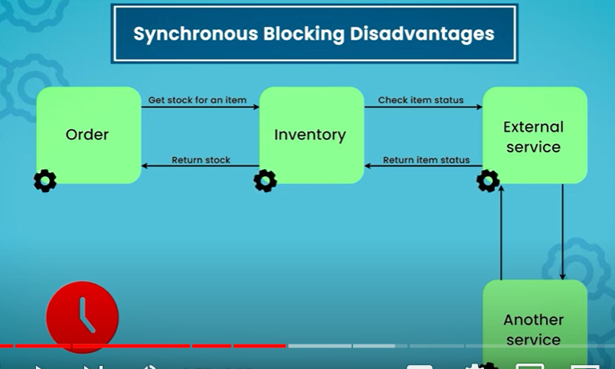

In asynchronous :

Order service send an event when customer placed an order to notification service

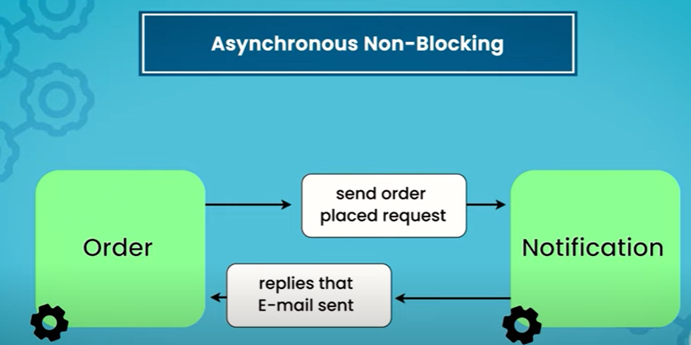

Order service will not wait for reply

3-----------------

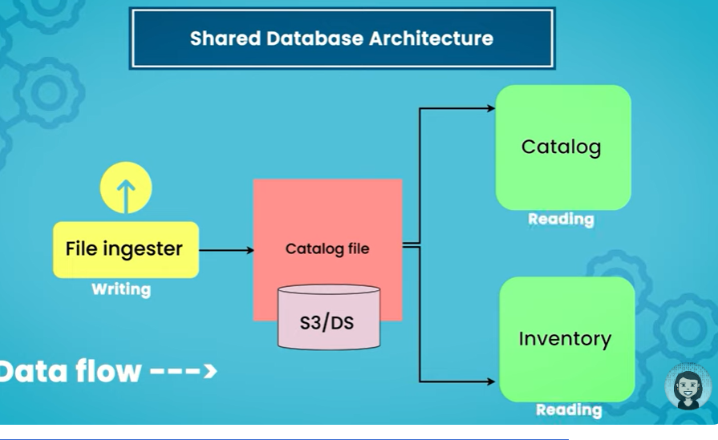

This is useful only one way as long as file ingester writing the data and other two service reading the data.

But when other two service start reading and writing both then problem arises :------

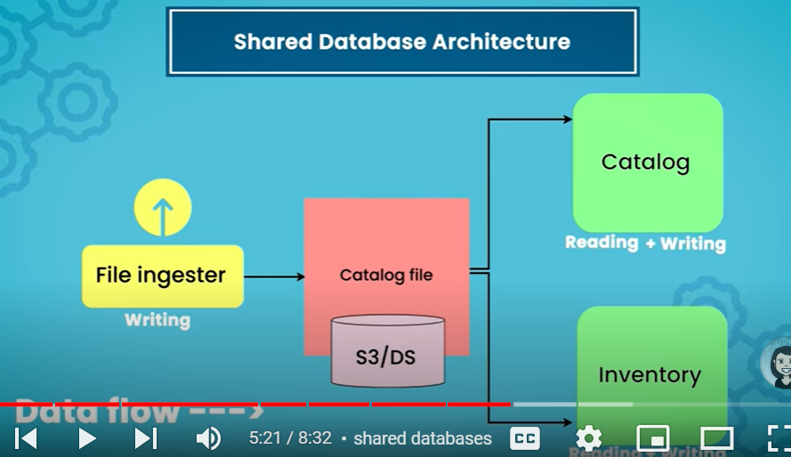

**Event based communication**

**There**  is topic in queue for which status of the order is pushed . these two services notification and inventory will consume the event but order service will not wait for any response.

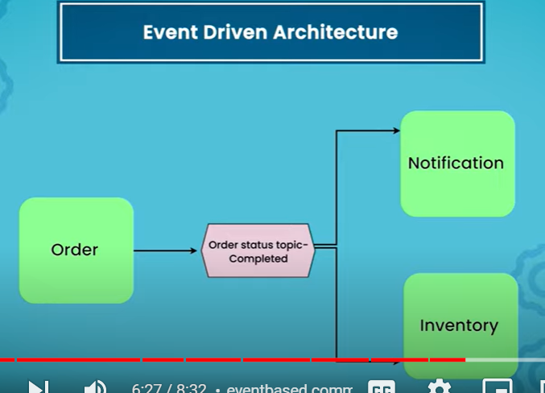

Advantages :---

The system become hugely decoupled.

# Lecture 3 : How to do Distributed Transactions the RIGHT way? Microservices

# Transaction in m/s is big and complicated problem to solve.

# In monolithic approach transaction is very easy ( since one database)

# We put lock , commit and release

# 

In case of m/s we have two diff databases , two diff services

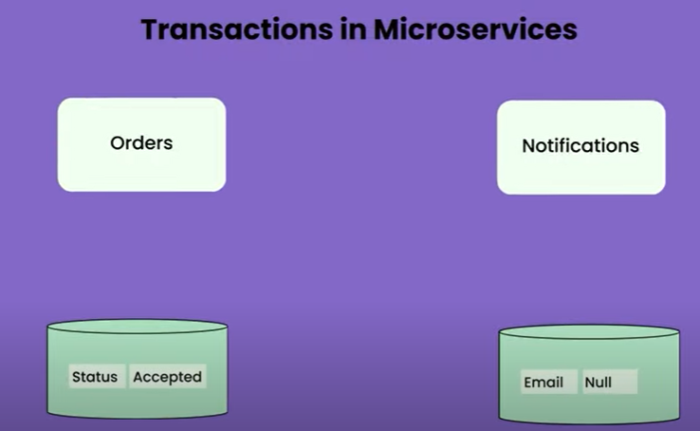

**If the state of one db is change and state of second is not updated then transaction is not completed**

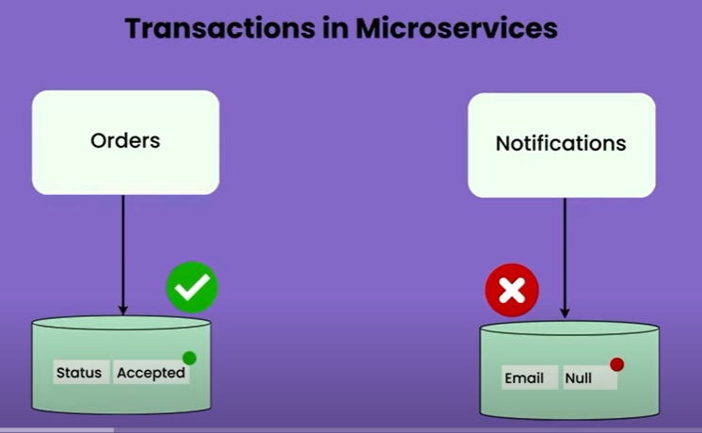

**Either we need to revert first one or make sure happen in second one**

**Query : how**  we achieve this in case of m/s

**One popular approach**

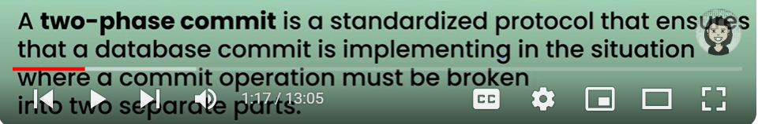

**We need to commit in two table at the same time**

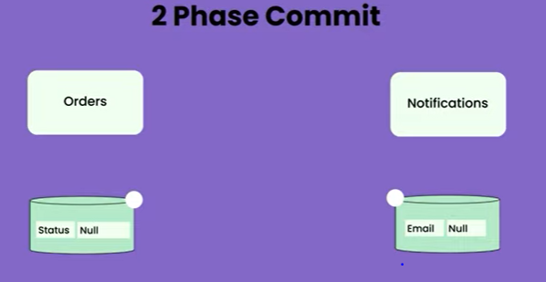

**In first phase coordinator will ask if they are ready for transaction and in second step both the services said yes we can update and now in the third step actual commit will happen and 4 step email is sent**

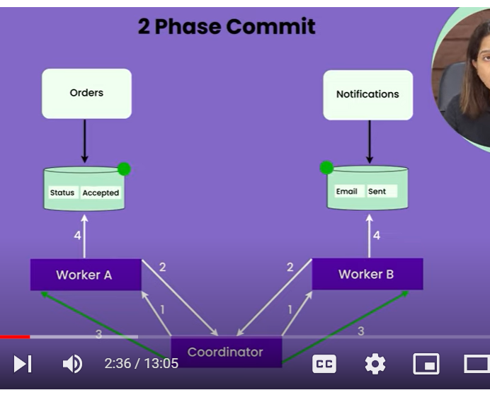

**Now how does this happen ?**

**After the second phase both the service will put a lock and once the commit happen lock will release**

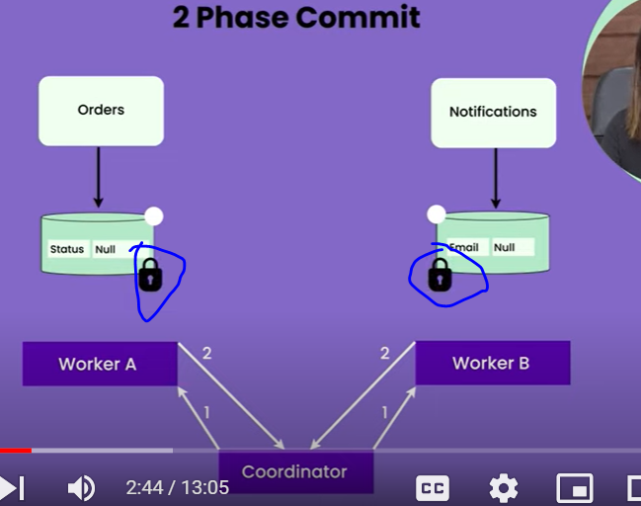

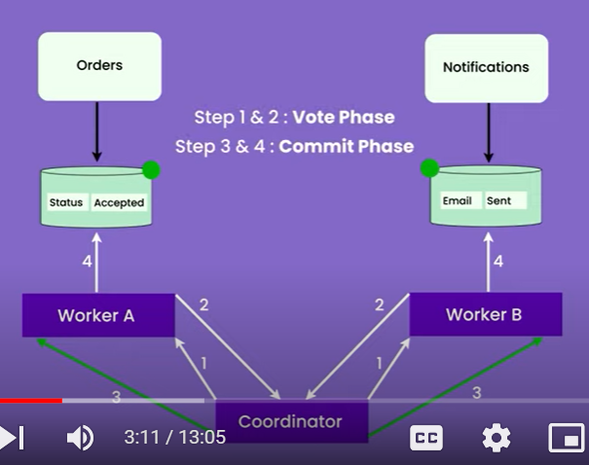

**But the problem come when we have a very big system**. Let say these d/b are huge.

Let say there are million of rows. Having lock on these d/b **will increase the latency of the system**

**How we solve this problem ? ---- long living transaction problem**

**Don’t do 2 commit approach :-**  it is risky

The actual solution is **saga approach**

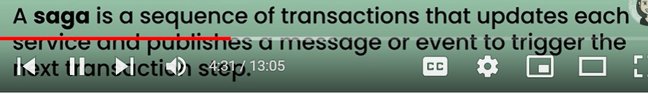

When a saga is executed, each step is executed in sequence. If all steps succeed, the saga is considered successful. However, if a step fails, the saga orchestrator triggers compensation actions for the preceding steps to undo their effects, ensuring consistency and integrity across the distributed system

**Solve the problem of updating distributed state in different system**

**There is a particular state maintained in all the service and it has to update it at the same time or in the same business transaction**

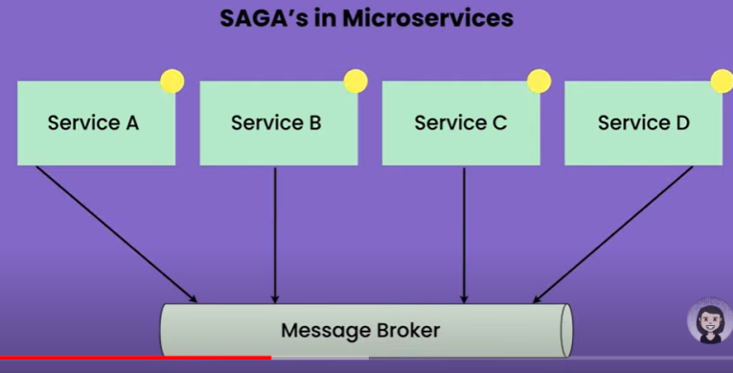

**Let see how**  transaction takes place in saga ?

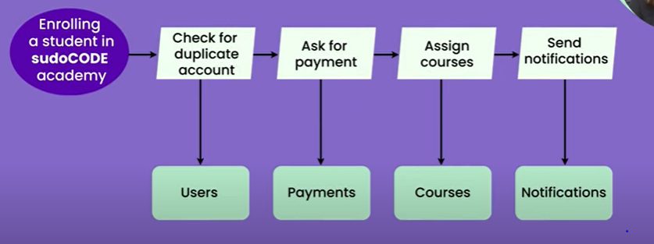

What happens if one of the step fails ?

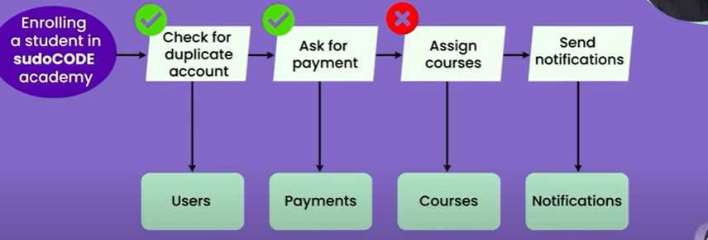

What u will do in this case ? will u refund the payment

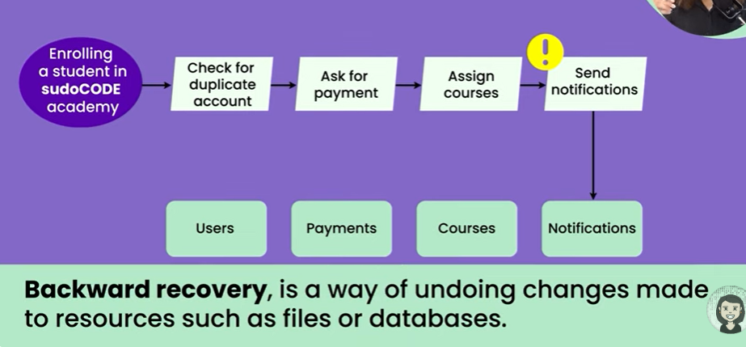

**One solution : backward recovery :------** go one step back return payment and send notification try again :

**Another solution : retry : this is called forward recovery**

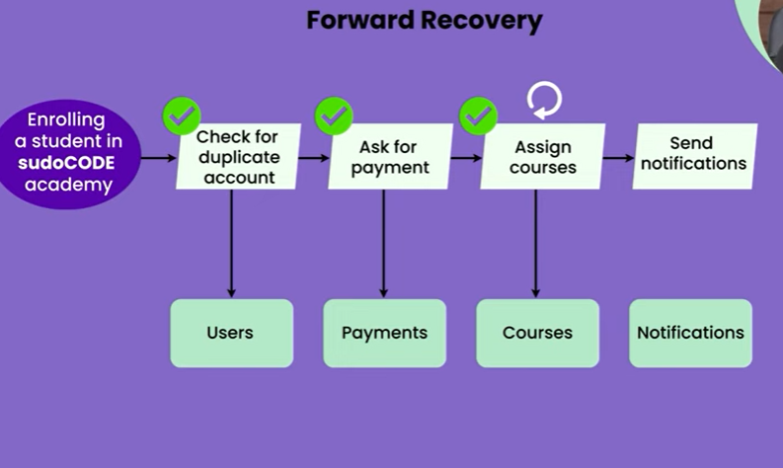

**It :**  is completely normal do forward and backward step both

But when talking **actual implementation** there are two ways of it :------------

**Orchestration approach ----- command and control approach ( like in music system)**

**Choreography approach ------trust and verify**

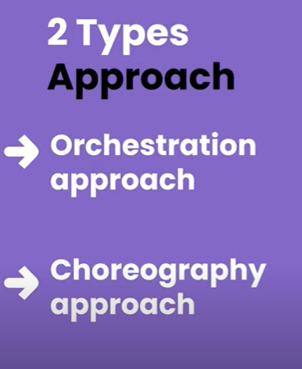

**Let see how does orchestration approach look like ?**

**User service :**  is going to act as orchestrator

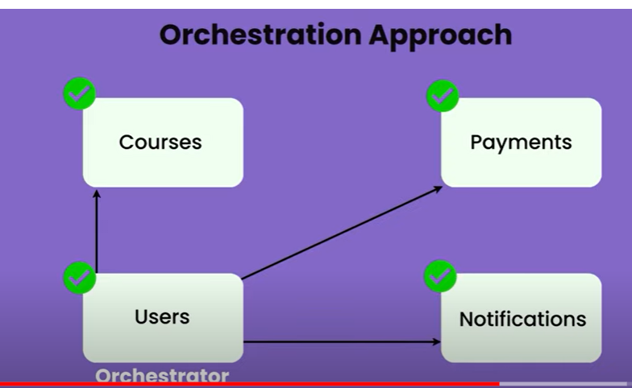

User service has control , it will talk to all service and give the command :----

U take course, u do payment, u send notification

**Basically user service has all the control and command. It is talking to diff service and telling what to do** So this is how orchestration approach look like

**How choreography looks like ?**

**There**  is no orchestrator

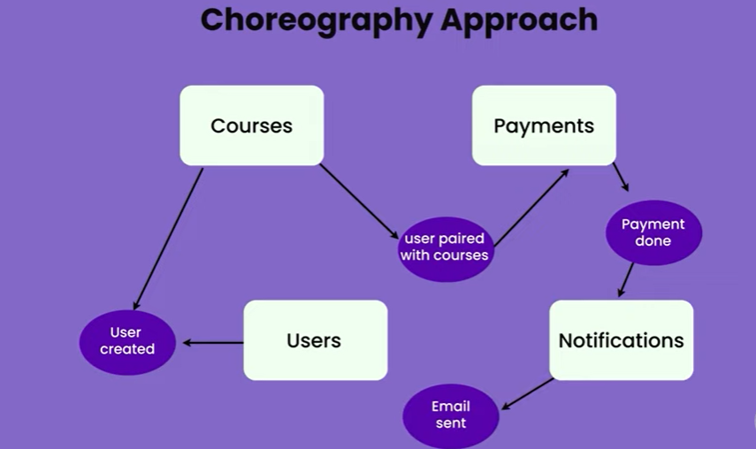

None of the service acting as orchestrator , all other service emits events and all other services reacting to those event to complete the whole business flow.

1. **Choreography-based Saga**: In this approach, each service participating in the saga knows how to perform its part of the transaction as well as how to compensate for it. Events are exchanged between services to trigger actions and compensations. This approach distributes the responsibility for coordinating the saga across multiple services.
2. **Orchestration-based Saga**: In this approach, there is a central component called the Saga Orchestrator, which coordinates the execution of the saga. The orchestrator sends commands to the participating services to execute each step and decides which compensating actions to trigger in case of failures. This approach centralizes the coordination logic in the orchestrator.

One of the failed they use to debug : **correlation id**

**Correlation ids** are unique identifiers that help you trace requests across multiple services in a distributed system. They are essential for debugging, logging, and monitoring the performance and behavior of your microservices

Correlation id help to see all the transaction across different services

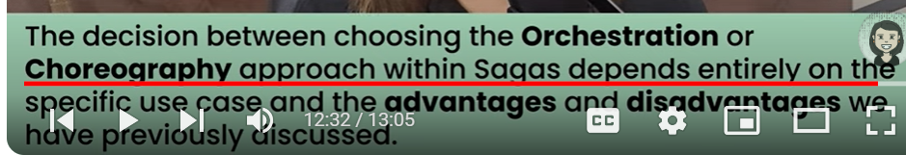

Logging and monitoring approach should be there

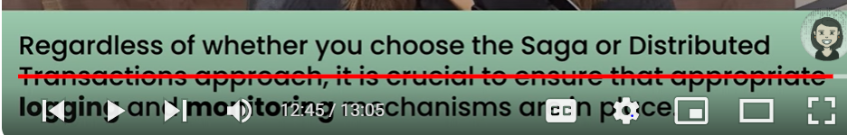

Each service is a system apart with its own database, and it is very hard to maintain data consistency. Saga pattern can help us maintain the data consistency among the microservices architecture efficiently. Event Sourcing ensures that all changes to business entity's state are stored as a sequence of events.

# Lecture 4 : How Event-Based Communication enhances Microservices Architecture?

# Event based communication help us in asynchronous communication

# Difference between a message an event ?

# 

**Message is the medium of communication or transfer of data**

**Whereas event is the payload sent over them or using that message**

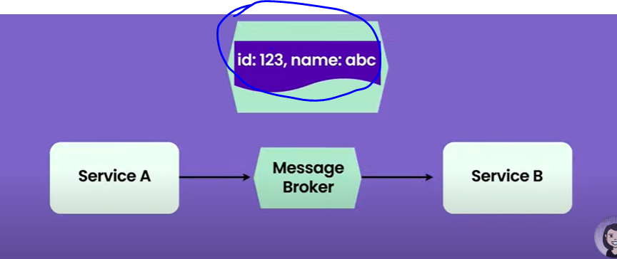

**Id:123 , name: abc--- is event and as a whole is packet or message which transfer through message broker**

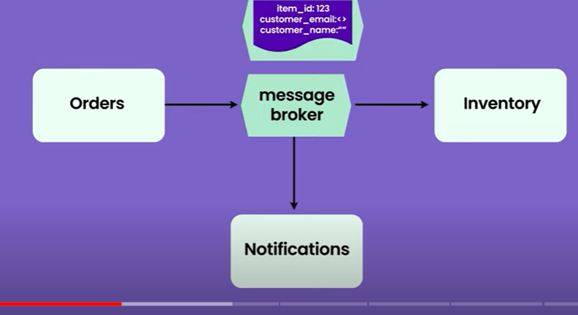

**Order : emit event**

**Notification : will use email id and name from event and send mail**

**Inventory : (will check availability of item)**

**Here we are giving extra info to inventory which does not needed**

**Problem :-**

We are **emitting one event which might be useful for some service while other it is not . if we can share this data to inventory then this is fine but there are some cases where we don’t want to show some data which is there in event to some service then this approach is not good**

**Or we don’t want event itself overloaded or we want to send separate event**

**Note :**  we can do that as well

This is one approach

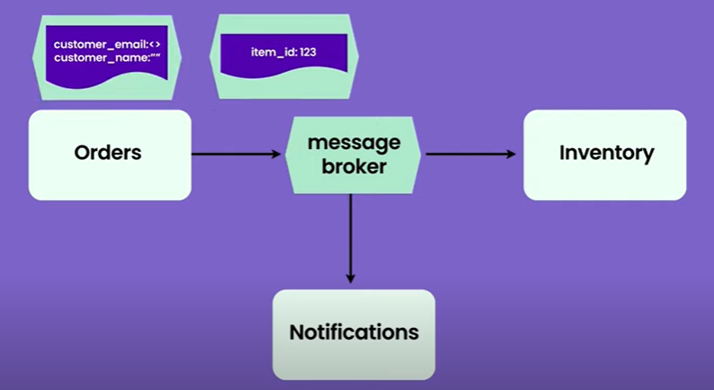

Or will take id and via request response (api call) will ask customer details

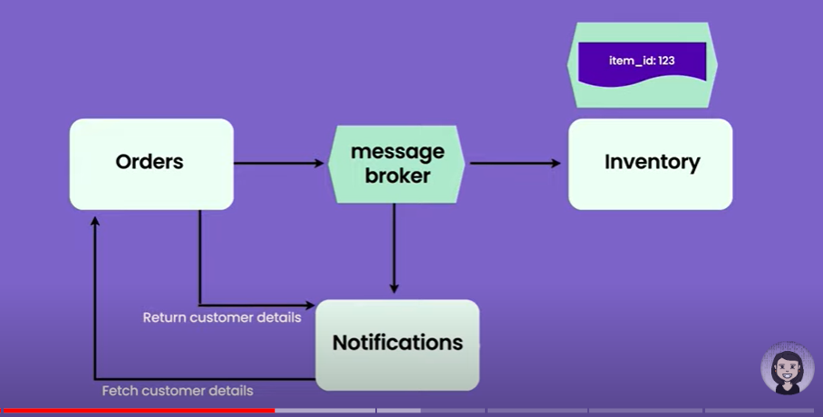

**But this is also a problem it will overloaded with so many api call**

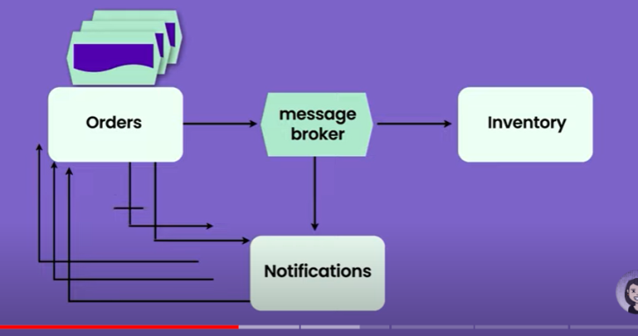

**The thumb rule :**  whatever the data we send over api we can send in event

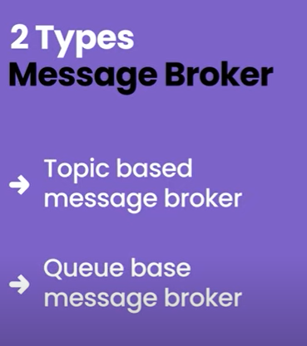

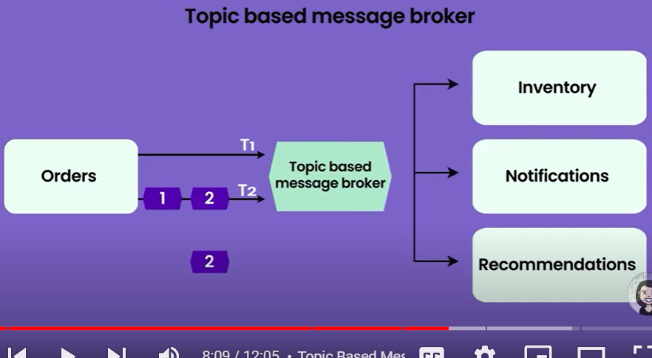

Note :

**Notification and recommendation both listening to topic T2** so there will 2 copy of messages----2

**When the message cannot consume in queue based ? how it is handled in queue based implementation**

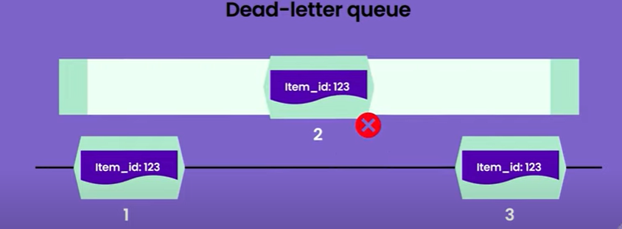

Message 2 will be removed from the main queue and placed in DLQ**( dead letter queue)**

**In case of kafka**

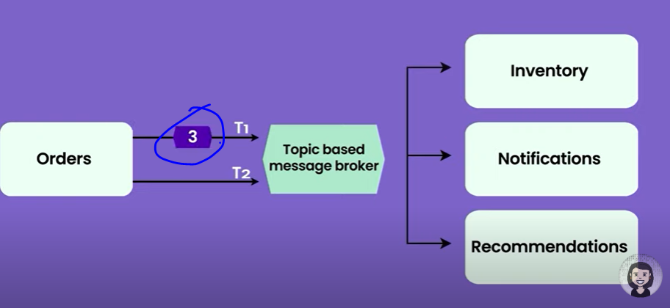

**We can retry message**

**Problem :**

**Message published but not consumed**

**Order of message is problem (not gurantee)**

**Consumer is down**

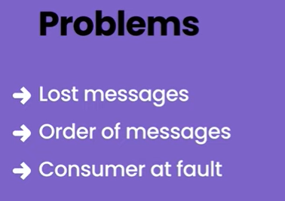

**Solution :-**

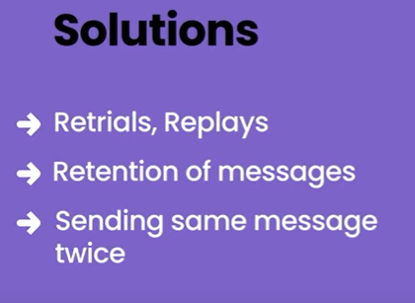

# Lecture 5 : Types of coupling in microservices and how to reduce it

# Note : we should know types of coupling before implementing m/s architecture.

# 

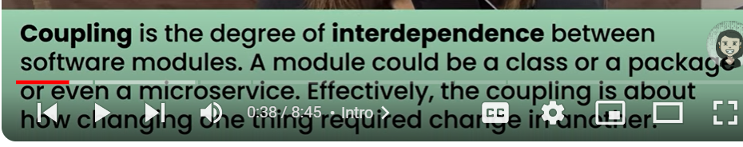

**If**  too much communication b/w m/s it will increase **latency**

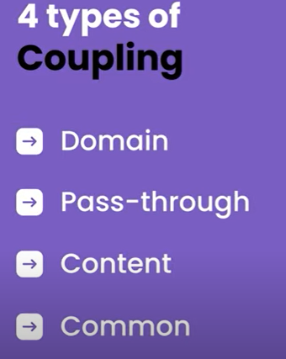

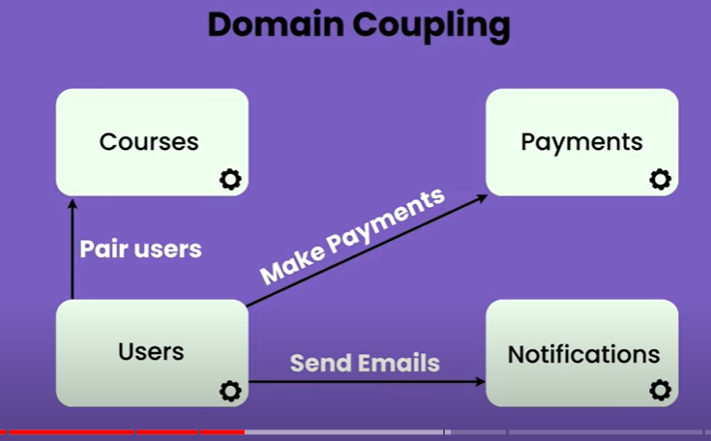

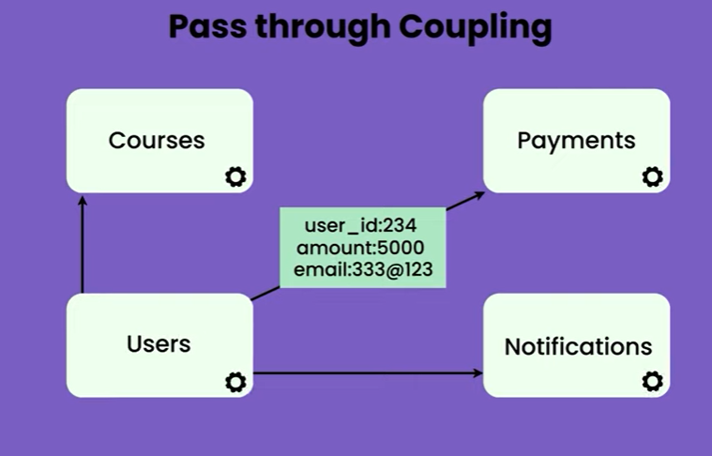

Now payment service have the info of user email which might not be needed.

Thumb rule : don’t share same d/b b/w two services atleast if both reading and writing happening.

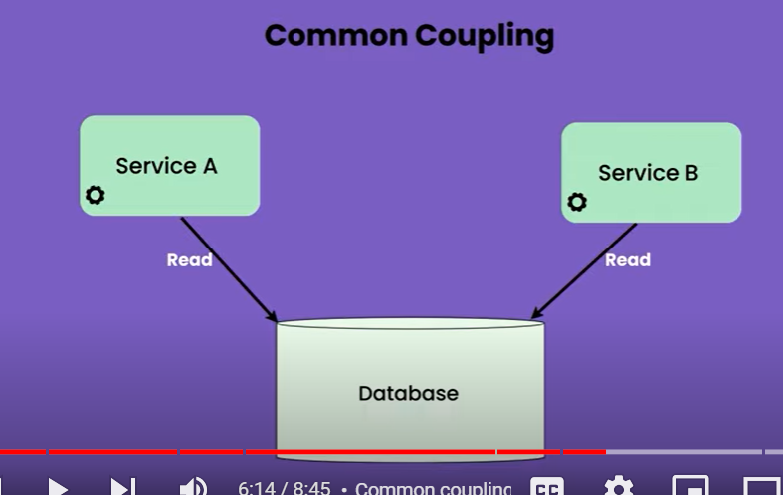

Might be ok if both are reading

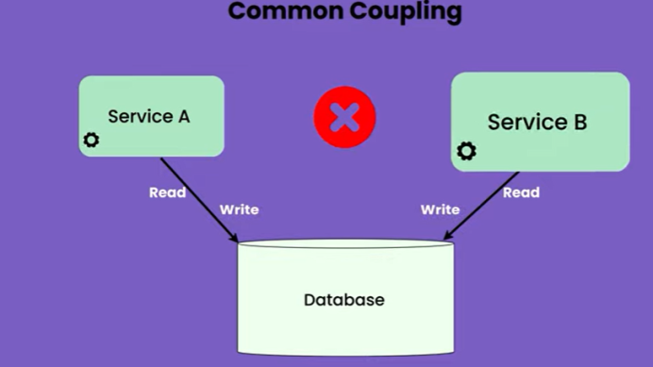

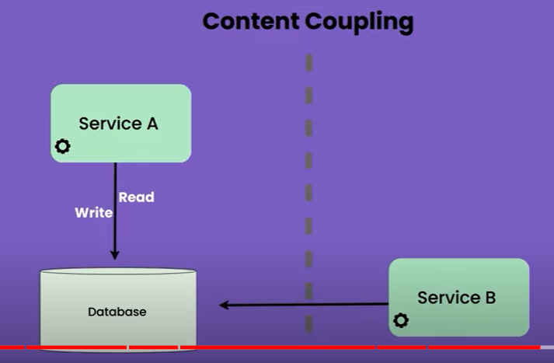

Note :

Two service are in diff domain and service b have the direct access of d/b. this should not happen.

Service b should get data by calling the api to service a

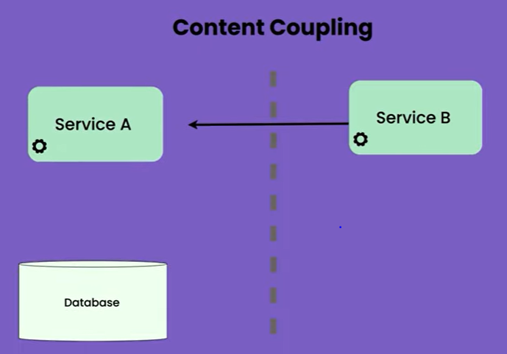

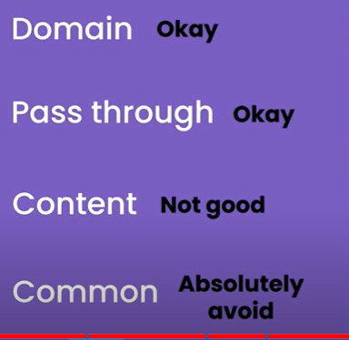

# Lecture 6: Monitoring Basics!

# 

# Lecture 7: Service Discovery in Microservices

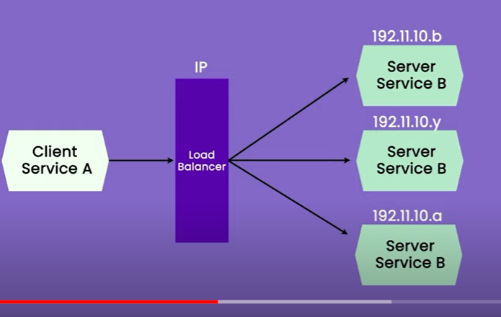

**Note** : every time any type of scaling occur, ip will get change

**Service registry** : will store the mapping between it service and corresponding instance

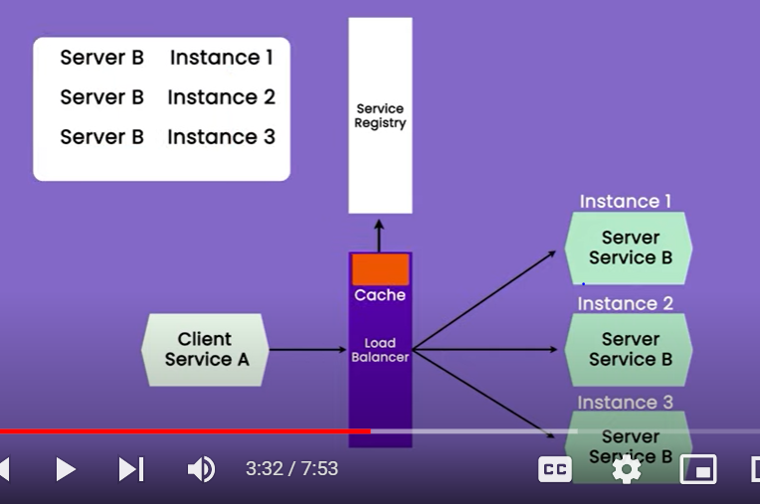

**Load balancer will ask where**  is the ip or it can cache also.

If new instance created it will register in service registry.

**Client side service discovery is also possible**

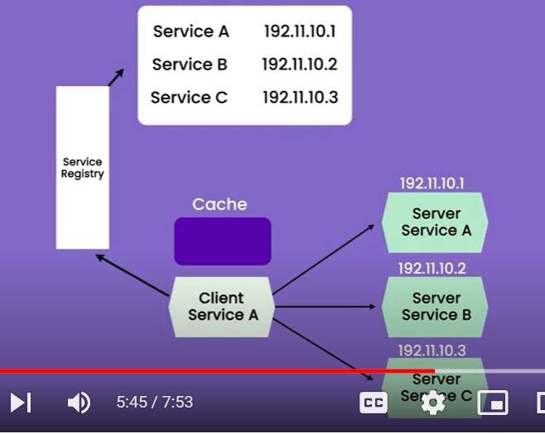

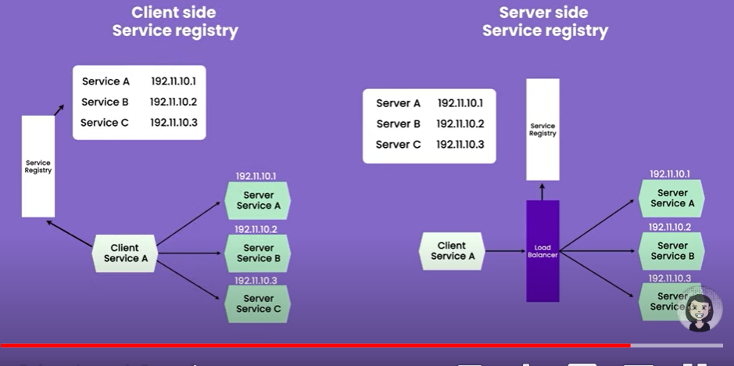

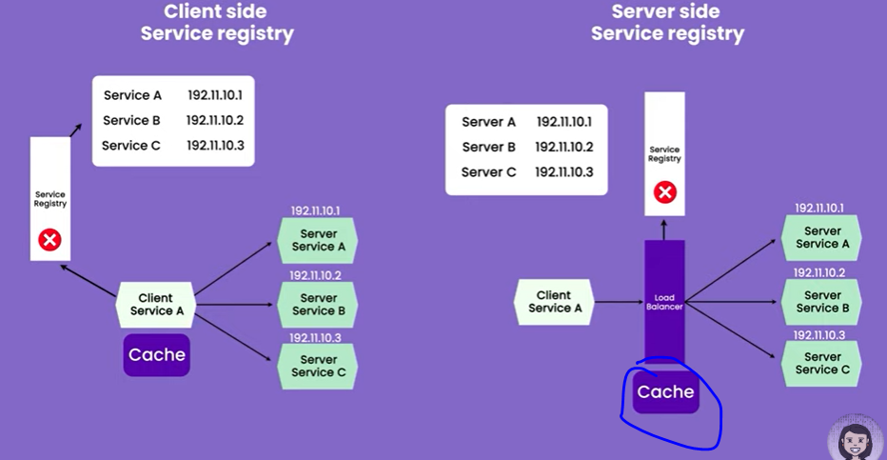

# Tutorial 8 :- Side Car Pattern in Microservices |

# 

# Side car will act as proxy

# 

**Whenever we want any kind of proxy mechanism we can use side car**

**A sidecar service isn't necessarily part of the application, but is connected to it. It goes wherever the parent application goes. Sidecars are supporting processes or services that are deployed with the primary application**.

# Tutorial 9 : What is event sourcing and how to apply it?

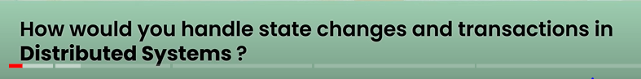

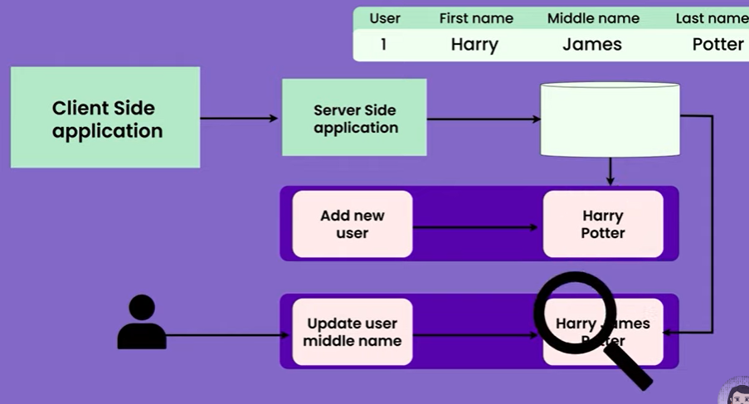

There is a scenario other client want to know who updated the **middle name**

**In earlier time we know order cancelled but in which stage it got cancelled we don’t know**

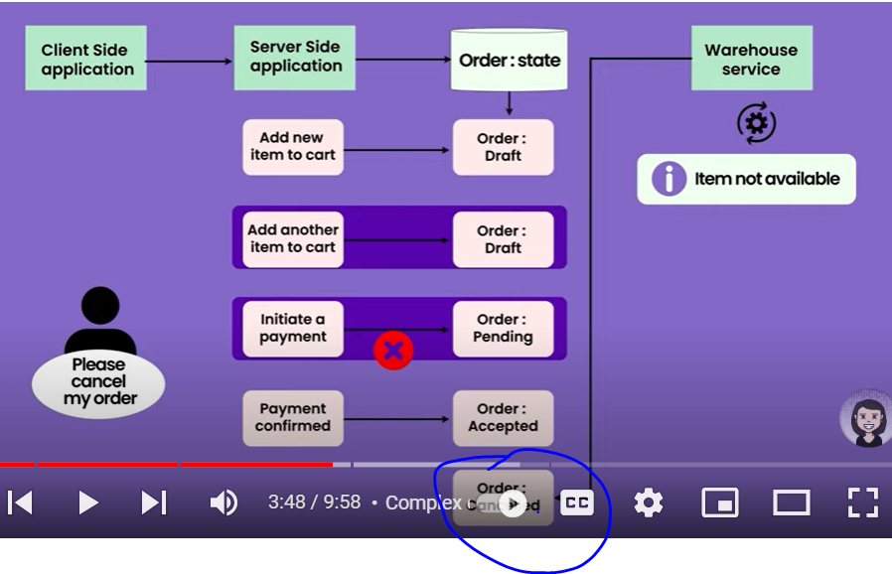

Anytime event occur that event will store in **event store**

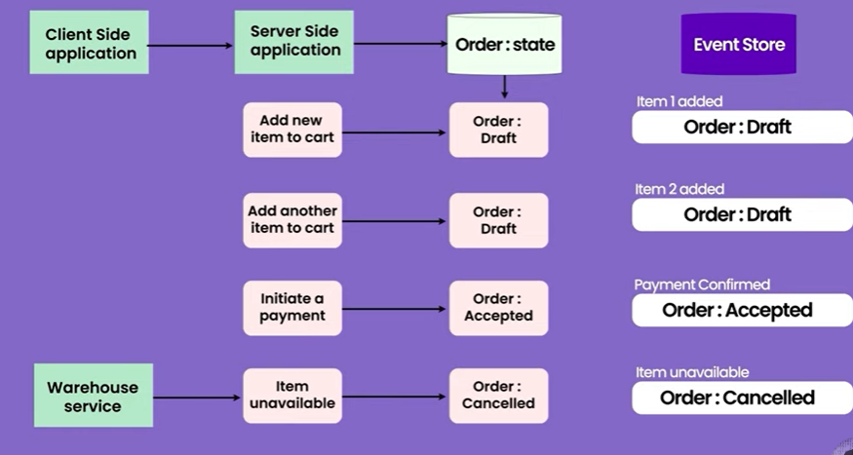

Payment failed :---- and due to event we can say retry the event

Server side passing events to kafka which may be store by some d/b

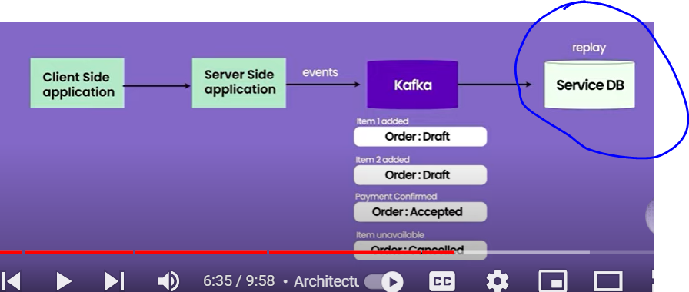

We can use audit log

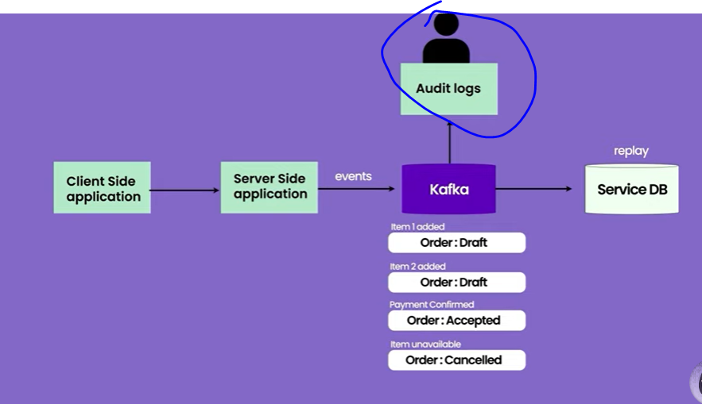

**CQRS : where we can separate read and write**

What is the CQRS pattern in microservices?

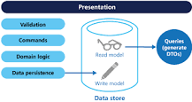

CQRS stands for Command and Query Responsibility Segregation, a pattern that separates read and update operations for a data store. Implementing CQRS in your application can maximize its performance, scalability, and security.

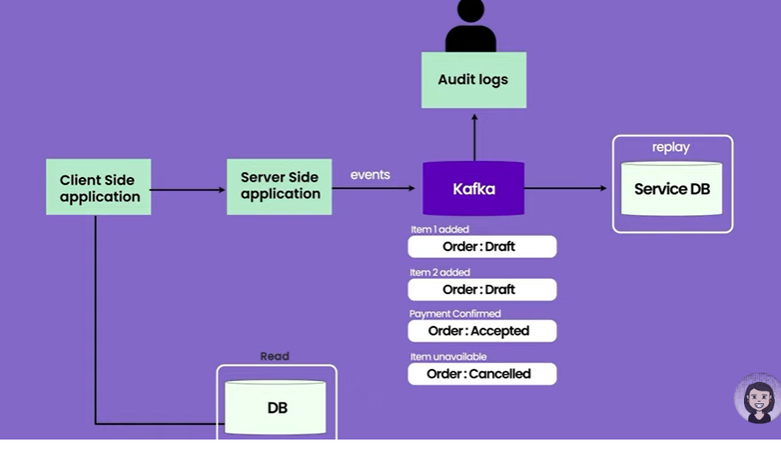

It is highly complex

# Lecture 10 : Introduction to circuit breaker in microservices

# 

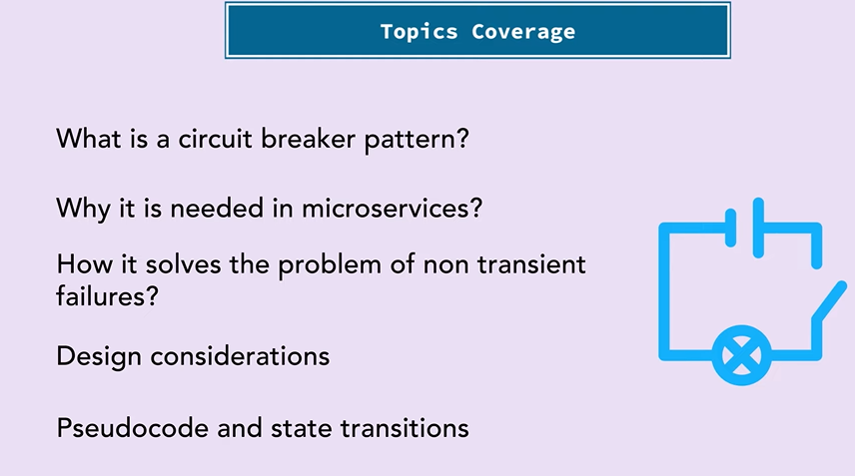

What is circuit design pattern ?

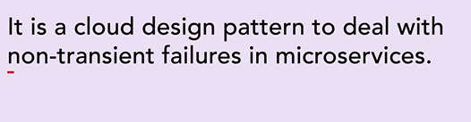

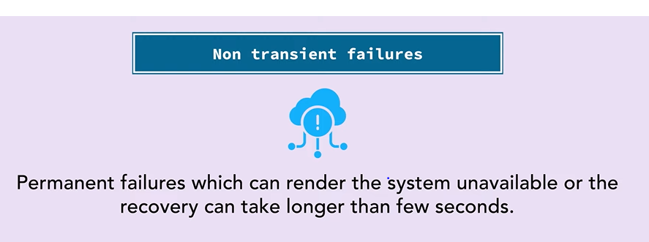

Example :

Timeout or delays where api do not response or take longer time to response resulting in timeout

Connection to databases failing

Service bombarded with lot of request and it failing due to memory or cpu issue

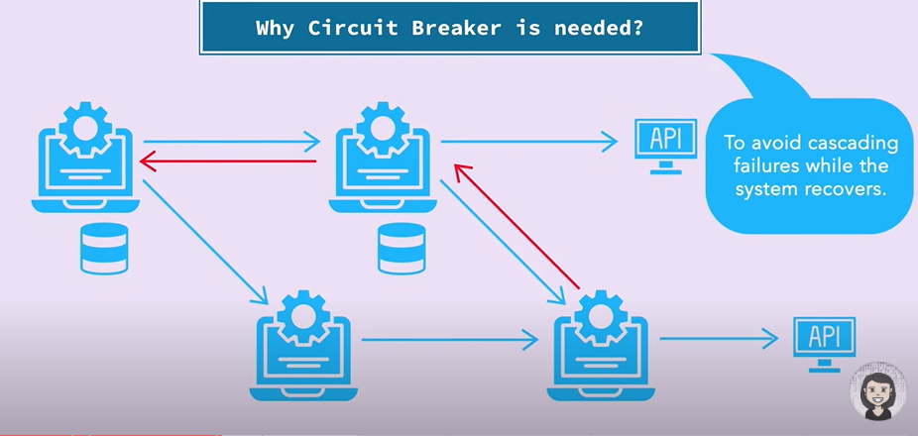

Where system might be down due to d/b and due to which other service also start failing

In such cases what will do will stop to call the failing service by applying circuit breaker pattern

Until the failing system recovers

